Analysis

I am planning to code a 2-dimensional game engine. I will use this to introduce young programmers to game creation. People see game creation as a long code intensive and hard project to undergo, so I hope to make it more accessible and easier for people of all ages to experience game creation without most of the coding. The code will also be user friendly with easily understandable variable and method names, meaning if someone would like to edit the source code, adding personalised features.

To find out some info about my target audience I will get them to answer the survey below. This will give me a range of data for my audience. These are some of the questions I will ask them:

* What is your age?
* What features would you like to see in a 2d game engine?
* What operating system do you use?
  + Window
  + macOS
  + Linux
* What processor do you use?
  + I 3/5/7/9
  + Ryzen 3/5/7
  + Other: please specify
* Do you have a graphics card? If so, please specify:
* Do you use a desktop or laptop?

Responses: (100 people)

* What is your age?
  + < 11 (7)
  + 11 – 18 (41)
  + 19 – 25 (32)
  + 26 – 65 (18)
  + 66+ (2)
* What features would you like to see in a 2d platformer? (most popular responses)
  + Easy to use
  + Intuitive editor design
  + Clear and editable code
  + Grouping/parenting objects
  + easy to add features in the source code
  + editable/customisable UI
* What operating system do you use?
  + Windows (77)
  + MacOS (14)
  + Linux (5)
  + Android (4)
* What processor do you use? (most popular descending)
  + I5 (27)
  + Ryzen 5 (21)
  + I3 (16)
  + Ryzen 7 (13)
  + Ryzen 3 (11)
  + I7 (10)
  + I9 (1)
  + Threadripper3990X (1)
* Do you have a graphics card?
  + No (48)
  + Gtx 1060 (15)
  + Gtx 1660 (12)
  + Gtx 1050 ti(7)
  + Rtx 3060 (3)
  + Rtx 3070 (2)
  + Rtx 2070 (1)
  + Rtx 2060 (1)
  + Rtx 3090 sli (1)
* Do you use a laptop or a desktop?
  + Laptop (58)
  + Desktop (38)
  + Phone (4)

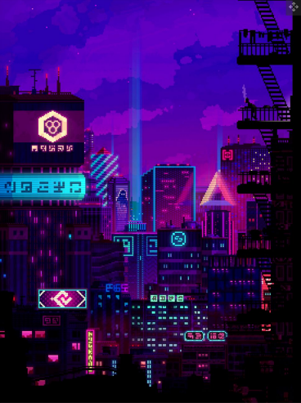From this I can get a basic description of the computers my game engine will be running on. As the majority of the survey had lower end hardware I need to make the code efficient and easy to run. I will do this by making the games textures low resolution, so it doesn’t take up a lot of memory on the system. This solution will also reduce the amount the computer has to render as the textures are smaller and simpler. I will also design it for windows as that is the majority of the user’s operating systems. Some responses to the survey were directed at the design of the UI of the game engine. I will make the engine easy to use and customisable for more experienced users. I hope to create a 2d game engine that can create games with a pixel art style. Some examples of this are below

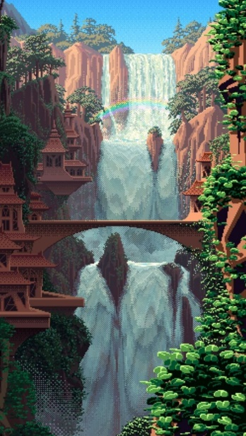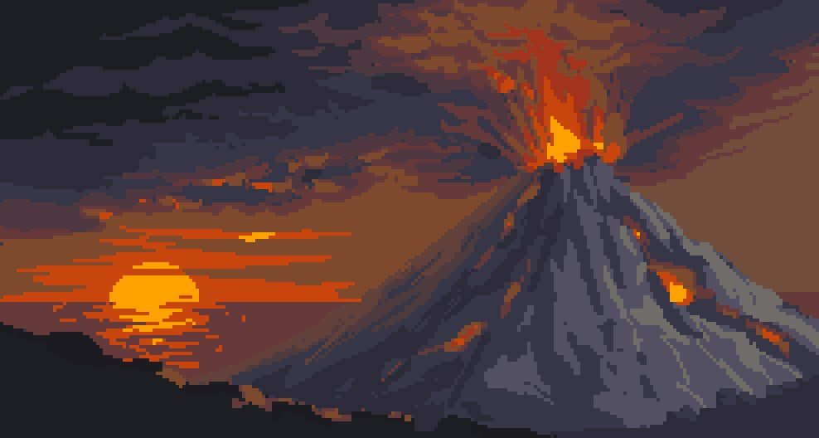Some examples of this pixel art style include:

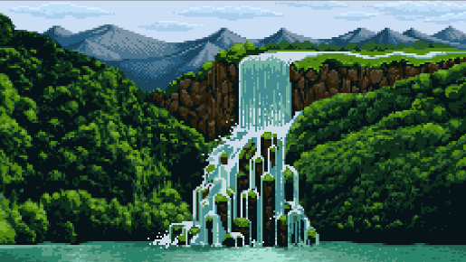

Source: Google images

Some games created in this engine will be able to have the following implemented:

Sonic mania:

* clear and distinct models for the characters
* bright visuals
* power ups
* different enemy types
* very fast paced level design
* mini games at checkpoints
* a lot of checkpoints along each level



Terraria:

Some ideas I will implement into my game:

* different areas and enemies
* possible day/night cycle
* being able to destroy the terrain
* being able to place terrain

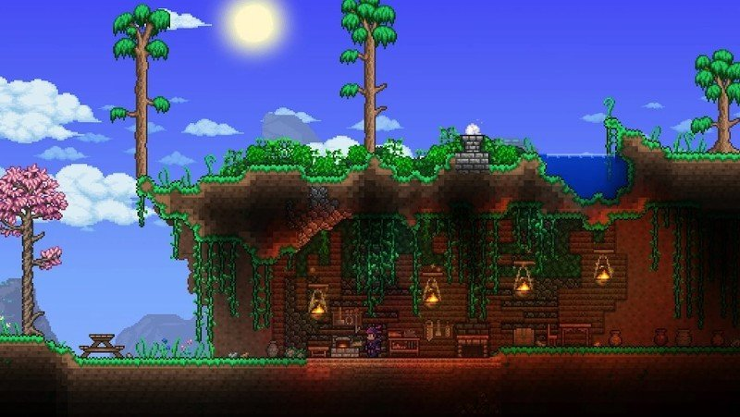

Game engine examples:

Unreal Engine:

* Ideas I will use:
  + Lists of objects in the game
  + Movable window panels
  + List of objects to import into the game
  + Game ViewPort
  + Save/Load
* Ideas I won’t use:
  + Icons to display buttons
  + Multiple instances of the game engine for different projects running at once
  + 3D game engine
  + Animation keyframing in the engine

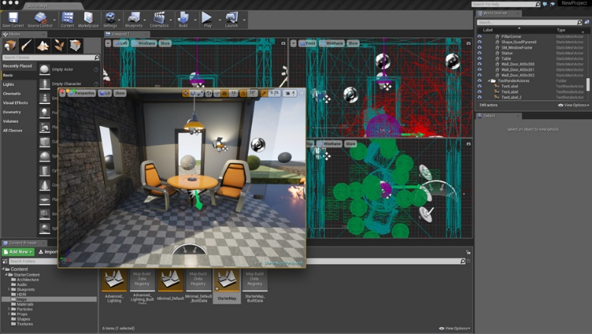

My objectives for this project are:

* Users will be able to download this project easily.
* Users will be able to save the progress of their game.
* Users should be able to edit the source code of their copy to add extra personalised features to their game engine
* Users should be able to create a game on one computer, save it and edit to on another computer, transferring the game by their own means (save game to usb/cloud storage)
* If there is an error when performing a task, the user will have a relevant error message explaining what the problem could be and where in the code it occurred.